Hagop Baronian’s play the Honorable Beggars and his contributions to İstanbul in his time
Ayşan Sönmez - Paris 8 University – IFG, PhD candidate
This content was prepared for Théâtre Ahazank - UGAB Paris. It was presented just after the performance the Honorable Beggars (Medzabativ Muratzganner) on May 26, 2019. For more information about Théâtre Ahazank, please visit the page: http://ugabfrance.org/programs/theatre/
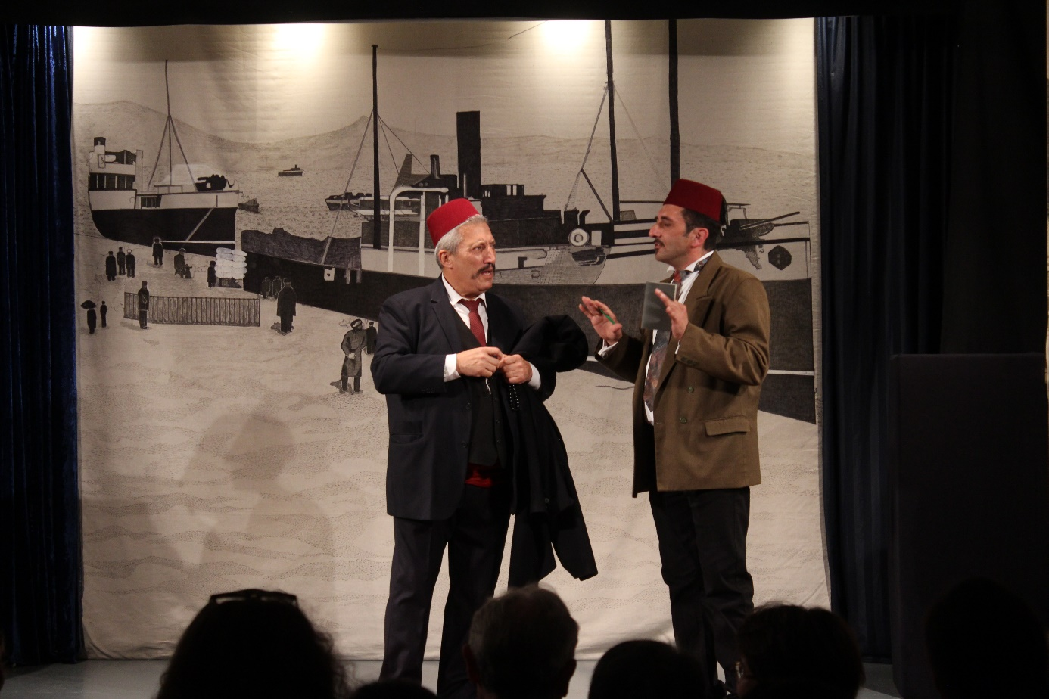
The Honorable Beggars, or Medzabativ Muratzganner in Armenian, is one of my favorite plays, and today we have watched a very good, professional performance of Théâtre Ahazank, thank you to the all who had contributed to the performance and thank you for having me here today.
Baronian wrote this play in 1881 after he returned to İstanbul from Edirne where he had stayed for some time because he was sick. 1880s were the years when the Ottoman Empire had been struggling with the after-war turmoil as well as escalating economic and political problems. The Empire was losing its territories, its unity, along with a severe economic and structural crisis. This is such a play that depicts the effects of a certain historical period to the lives of people very well. Baronian, as a playwriter, told us how the poverty was felt in Ottoman capital, in İstanbul/Bolis in an artistic way without being didactic which was rare in his period indeed. He told us the changing values along with the historical developments. At that time, the Armenian intelligentsia of İstanbul had culture but no money, they were living at the edge of hunger indeed. This was valid for Baronian himself too. The merchant from Trabzon, Apisoğom Ağa was a member of newly emerging class, he was rich but had no culture. Unlike Western ports, Eastern ports of Black Sea were developing and therefore, the community there was getting richer. Apisoğom Ağa came to İstanbul to get culture, and the İstanbul community, who saw him mainly as a source of money, invited him to make a trade such that Apisoğom Ağa would give them money and in return, he would get prestige in the community of İstanbul. Baronian put each and every member of the community via its representatives in the play into this “trade”. He showed this situation as a reality with his political satirical language and interpreted it as a corruption. For him the intelligentsia had been reduced themselves into the beggars who were begging for money from a simple merchant. The İstanbul insisted so much that Apisoğom Ağa cancelled his plans in the end and run away from the İstanbul without looking his back again. Baronian was pessimistic about the situation indeed. I want to talk briefly about why Baronian has become so pessimistic about the community as well as about the situation in the Empire.
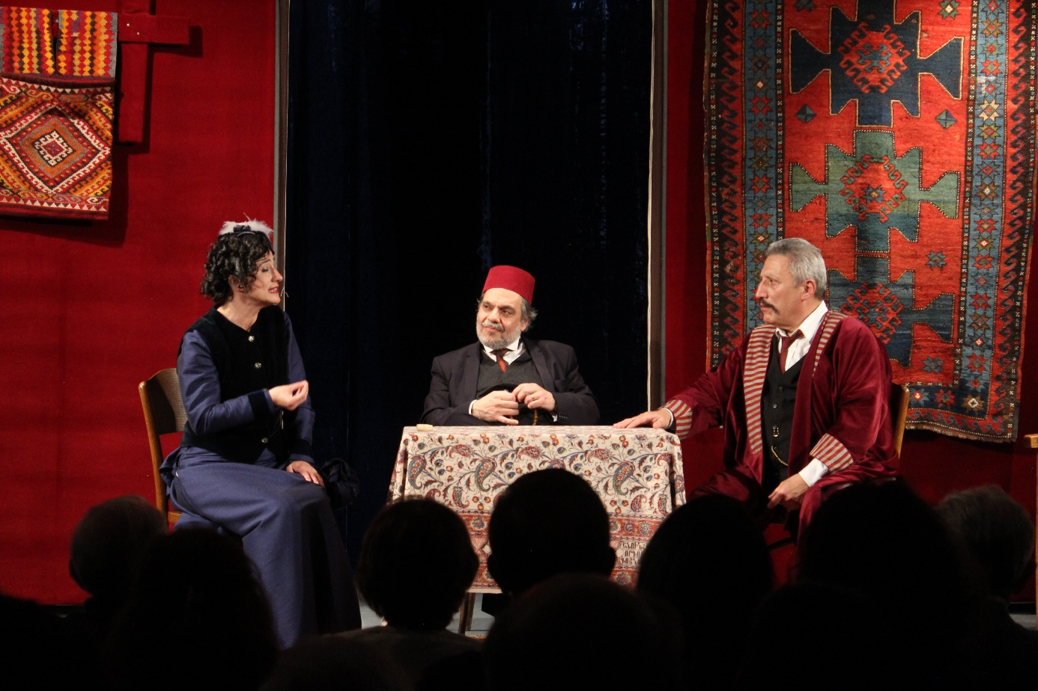Baronian as a child of Tanzimat: Hopes vs disappointments
The spirit of the century was shaped by revolutions changing the world deeply. The world order was changing politically and geopolitically after important global trends – i.e. French revolution (1789), Industrial revolution and American revolution (1765- 1783). For Ottomans it meant adopting new ways to govern, new ways for trading, etc. to survive as traditional Ottomans system was in contradiction with the requirements of these global trends. The Empire was losing its territories, its unity was under threat, it was in economic/politic/social crisis; in brief, it was in a deep systemic crisis. Ottomans as a colonial power of the previous centuries was in the process of colonization.
Global trend was nationalisms; nations were in the process of state-making. On the other hand, the Ottoman Empire was an empire; its traditional system was established based on the religious communities and superiority of Muslim subjects as well as its government structure was decentralized; more like based on federal regions. So, nationalism was a threat against its unity.
Within this panorama, the 19th century was a struggle of survival for Ottomans. For keeping the integrity, the Empire initiated a process of Westernization as a solution for the systemic crisis; it started its own modernity. This process had started in the first years of 18th century but it became more mature and decided during the 19th century. Ottomans had to integrate into the global economy (signed free trade agreement in 1838 with Britain for example) and update its system to meet the changing requirements. It was a process of reshaping the Empire’s traditional state structure as well as it was a reorganization process for the communities of the Empire. This was not only international prerequisite, there were also local demands for change.
One of the main reasons that forced the millet system to change was the rise of new entrepreneurial-commercial elites - a secular intelligentsia (Muslims and non-Muslims alike). They were making trade with European countries and so in contact with the international markets, they were mostly educated in Europe and influenced by French secularism, anticipated the future of their communities on more secular national grounds. Their economic and political claims and interests conflicted with the traditional millet system and Ottoman concepts of authority.
In parallel with international and domestic requirements, the Empire made 2 official declarations on this issue as part of its domestic and international obligations: Gülhane Rescript in 1839 and Reform Edict in 1856. Among these the latter one is more focused on socials reforms; the most importantly provided the conditions for the constitutions of the communities/millets. It provided a new framework for the rights and privileges of Christian and Jewish communities and the right to be represented in the general assembly. So, it implied the equality among all the subjects of the Empire with the aim to create a new identity definition (as a nation) as Ottomans for example. It implied the possibility of a common Ottoman citizenship and loyalty to the dynasty, irrespective of religion or ethnicity. The Armenian Constitution (in 1860, 1863 and 1868) was part of this process which witnessed strong power struggles among Muslims as well as Christians (ulema vs modern Muslims; Armenian new bourgeois vs amira class – i.e. traditional Armenian aristocrats). As you know well, during the same period, Jewish community’s Constitution (1865) and Greek/Rum community’s Constitution (1862) were prepared as well.
Hagop Baronian was a witness and an active figure in this historical background. He was close to this Western-educated Young Armenians and the strengthening new social class within the Armenian community who trades with Europe, who created a new Armenian intellectual generation, who knows the Western culture. As you know well, this generation demanded redefining its traditional religious bodies of the community and established its own modern education system, its own modernity.
During 1860s, Baronian was an active journalist and writer. He supported Armenian Constitution because it might have introduced a large degree of secularization in the community and equality among the subjects of the Empire. Then he started to believe that the Constitution was an inadequate tool for these intentions because neither the Ottoman government nor the Armenian authorities made enough effort to improve the living conditions of people in the Eastern provinces. For making improvements in the Constitution, he joined forces with some Armenian leaders to propose amendments for the Constitution document.
When the Constitution was restored in 1868, Baronian and many other Armenians strongly believed that it would provide the community with a just administration, guarantee a secure life for the Armenians in the provinces and secularize the government of the community. Moreover, he believed that the Constitution would be a response to the emerging nationalist feelings amongst the Armenians and would prove an effective tool for restoring the disintegrated unity of his community. In these days, there were still hopes to live together as the communities of the region, and so like many others, Baronian supported this idea hectically.
On the other hand, political developments or choices did not allow this generation to achieve their goals. This generation lost unfortunately. Ottomans debts, political instability, political conflicts in Balkan, etc. soon led the Empire into the wars. Baronian, like the others who supported Constitutions processes, started to be hopeless about the capacity of Ottoman government as well as Armenian authorities to protect the rights of people and solve the prevailing urgent issues. The critical turning point was 1875, the events in the Balkans led to the Eastern Crisis of 1875-78 and this led to informally cancellation of the constitution process for a long time, until the second constitution in 1908.
Therefore, when Baronian wrote this play in 1881, the Empire was at the edge of another turning point that made Baronian so pessimistic about the prevailing situation. Let me mention chronologically: in 1874-75, Balkan resistances as well as famine in central Anatolia and Eastern provinces; in 1876, bankruptcy of the Ottoman government; in 1877-78, Ottoman Russian war; in 1878, Berlin Treaty, in 1879, another famine in the region.
And beyond these, in 1878, the Ottoman general assembly was closed by the Sultan Abdülhamit II. It was opened again in 1908 again with the second constitution with another optimistic tone but you know, the next year, in 1909, Adana resistance had happened.
So, the Honorable Beggars was written with this historical background.
And now I want to talk about Baronian’s contributions to İstanbul during Tanzimat.
Baronian’s contributions to İstanbul in his time
Baronian, like his contemporaries, was a multidisciplinary and multilingual man with multiple professions and identities. The members of this generation were not only writers following a specific genre (be it theatre plays), but also linguists improving their native language, who were competent in European and Ottoman languages, etc. At the same time, they were, for example, accountants or artisans for affording their life with, so they also had basic knowledge in trade and craft. They contributed to the Ottoman Empire in various ways in parallel to their competences and identities. So do Baronian, he contributed to İstanbul/Bolis in many ways: as a publisher, as a playwriter, as a theatre critic especially with his support to the Ottoman state theatre of these days: Gedikpaşa Tiyatrosu – Tiyatro-i Osmani.
Baronian as a Tanzimat publisher
During 1860s, Baronian was a prolific journalist and writer in his community, writing in Armenian. After 1870, he started to publish in Ottoman Turkish to reach wider public with the change of publications policy of the Empire. Starting with 1830s, Ottoman publications were mainly state-running publications; journalists/publishers were mostly state officials. The purpose of the press in these years was to inform the bureaucrats about the official politics of the Empire and to transmit the official discourses to the officials around the Empire.
With 1870s, the Ottoman Government (Bab-ı Âli) allowed independent publications and gave licenses to independent publishers. The purpose was to support government’s efforts of modernization via publications as well as to strengthen the communication with the public about the reforms. Therefore, the press started to have a power to create a “public opinion” under the control of Bab-ı Âli and it continued until 1877 with strict control of the official censor committee. After that date, publications were banned.
Reaching wider audience with publications meant to use Ottoman Turkish in printed media. So, to communicate with the audience who only read/speak Turkish, the publishers started to publish their content in Ottoman Turkish beside publishing community publications in French, Italian, Greek, Armenian, Ladino or Bulgarian. Therefore, the content of these newspapers went far beyond only conveying the states politic and its discourse. They included daily social and individual issues ranging from urbanization to the habits of the ordinary people and reflections of Westernization/Modernization attempts in daily lives. The Ottoman government supported these publications underlying their mission in explaining the reforms and Westernization politics to common people. Since these periodicals criticized domestic and international politics of the Ottoman state at the same time, they also faced censorship and bans by the Ottoman government. Baronian’s periodical were closed many times by the censor committee.
Baronian also adopted this policy along with other Tanzimat intellectuals. While he was publishing Tadron (Theater) in Armenian for the Armenian community of İstanbul, in 1874, he handed over its editorship to his friend and launched the satirical periodical Tiyatro (Theatre) (1874-1875) in Turkish in Arabic characters. With his periodical, Baronian’s main purpose was to train Ottoman community who could only read and speak in Turkish on theater, literature and social issues through theatre and theatrical/satirical language.
Baronian as a political satirist
Baronian was categorized within the first generation of Armenian satire tradition by Anahide Ter. Minassian. His subject was the human’s moral balance and welfare of the people (both his community and the general Ottoman public). His political satire covered a wide range of topics: the problems of Armenian political life of the time, internal and external Ottoman policy, and international relations, vices of men and women, etc. His political satire was so harsh that he was not welcomed by the authorities of his community as well as Ottoman government. With his novels, articles and stories, he exposed the incompetent performance of Armenian public figures, the Patriarch, and the leaders active in the administrative structure in the community.
He is named among the dominant figures in Western Armenian literature in the 1870s and the 1880s. Kevork Bardakjian places him to the period representing a transition from Romanticism to Realism. He was also a popular writer among Eastern Armenians. After 1877, following the reign of Abdülhamid II and Ottoman-Russian war, we started to publish his works in Caucasian Armenian press because the press as well as theatre were banned then.
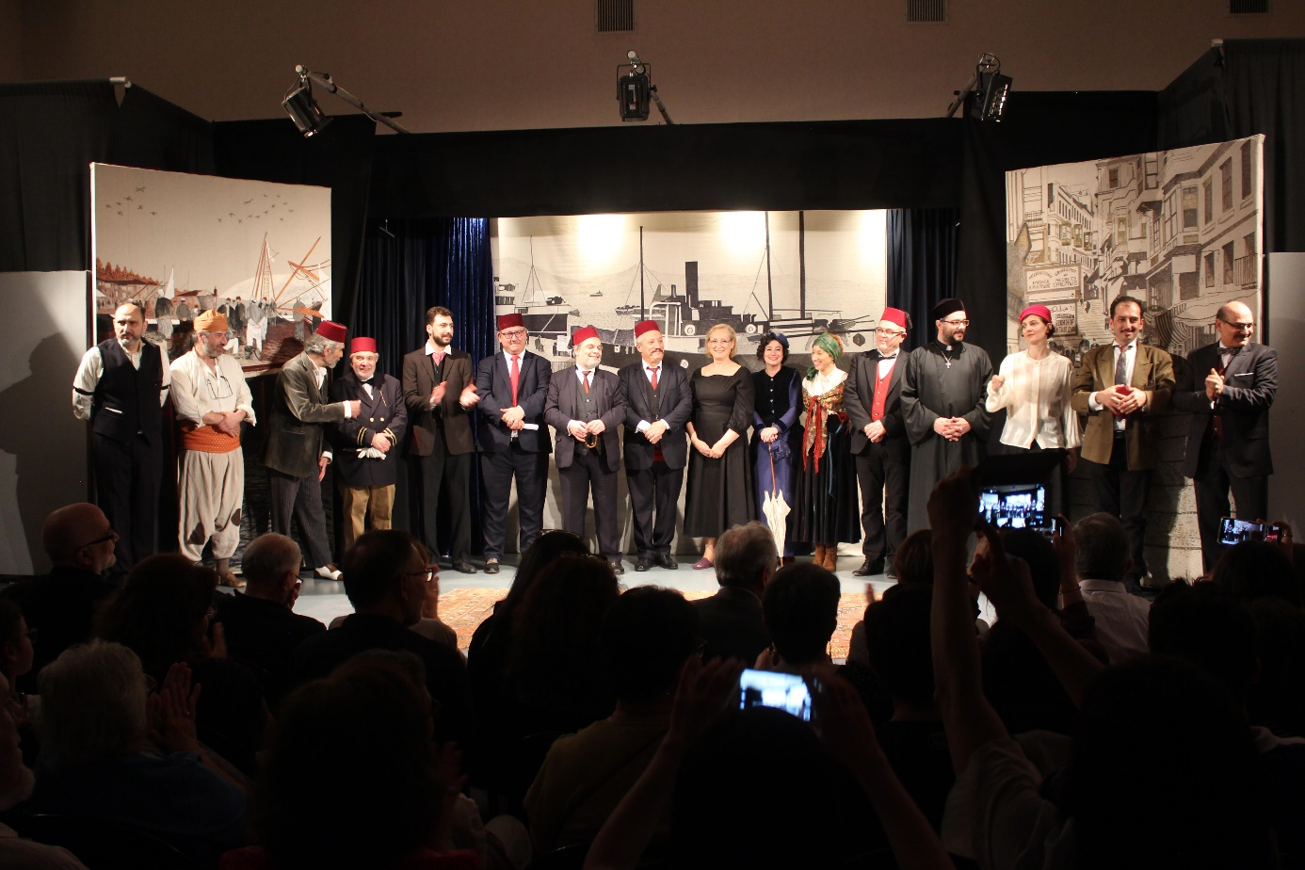Baronian as a playwriter and theatre critic
He was one of the first representatives of modern Armenian/Ottoman theatre in Bolis/İstanbul. He was competent in world classics especially in Italian and French tradition; namely Molière and Goldoni. He wrote his early adaptation a Servant with Two Masters (Yergu derov dzara mı) (1865) inspiring from Goldoni’s A Servant of Two Masters. In 1869 he wrote, the Eastern Dentist (Adamnapuyjn arevelyan) which was not direct adaptation but included Molièresque scenes like in your play the Honorable Beggars. These plays shared many similarities with Molière’s plays beyond being imitating them. Baronian’s adaptation of Molièresque style is different than Teodor Kasap Efendi or Ahmet Vefik Paşa’s Molière adaptations. These names adapted the Molière plays into Ottoman Turkish by localizing them but Baronian adopted Molière’s style and recreated his own pieces inspired from Molière’s style. Considering also his latest play, the Brother Balthazar (Bağdasar Ahpar) (1887), Baronian’s plays are considered as the masterpieces in political satire and comedy tradition in Western format in Ottoman Empire which had artistic value beyond being didactic.
He can be considered as the second generation of Armenian Theater movement shaped in Mechitarist schools in İstanbul. Baronian was nurtured by a strong theatre movement among Armenians during and after 1850s which was brought by the graduates of Mechitarist schools in Venice, Paris and in İstanbul with Armenian modernist school/community theatre organizations. As you know well, Ottoman modern theatre was a product of the students of the graduates of Mechitarist schools. He raised, for example, with the tradition established by Aramyan theatre (1846-1866), Ortaköy theatre founded then by Mıgırdıç Besiktaşlıyan in 1856, and Pera Group founded in 1856 by Sırabiyon Hekimyan.
Beside producing the samples of modern theatre, he also supported the idea of having a modern national/state theatre of Ottomans during the Tiyatro-i Osmani (1870-1908) of Hagop Vartovyan (Güllü Agop). Baronian so motivated to support Gedikpaşa Tiyatrosu. He saw this initiative as the possibility of having a “national theatre” representing the “Ottoman nation” (in consistent with the Tanzimat idea) instead of being a product of certain millet/community. In his periodical Tiyatro, he asked: “Turkestan would always fall short of Europe? Why our theatres should not stage equally good plays as Europe and why we should not try to go beyond the European theaters?” He was one of the first theatre critics of İstanbul as well. In Tiyatro, we can read his critics on theatre infrastructure, quality of the plays, how to watch a theatre play, etc.
In his Tiyatro, he also conveyed his criticism to urbanization issues of the İstanbul by highlighting he “inabilities” of the municipality listing the problems in transportation, water issue, ships, etc. again with his theatrical/satirical language. He elaborated economic issues in human level, problems in adapting western traditions and generation gaps in meeting with the West/Western ideas and its reflections on daily life, he wrote on love affairs, fashion, daily habits, of Ottoman Empire during his age.
In Turkey, Baronian has been an invisible satirist and theatre person until recently. But some of his works were translated from Armenian to Turkish or Turkish transcriptions were published. With the language/alphabet change, contemporary readers could not read the Ottoman languages including Ottoman Turkish with Arabic alphabet. And few people could read in Armenian. Therefore, the publications of this generation were hidden to new generations. Therefore, their contributions to İstanbul/Bolis was not so well-known. Baronian was one of them. We know that he is still relevant for the new generations in Turkey. As you may know, in 2011, İstanbul Municipality Theatre staged Baronian’s the Eastern Dentist (Adamnapuyjn arevelyan) and the theatre hall was full of young people. They watched Baronian with joy and laughter. It shows that he is still relevant in his society of Bolis. It clearly shows that, making this generation more visible with their works is very important in parallel with political efforts for memory works on this direction.
Bibliography
Bardakjian, Kevork B.. 2013. Modern Ermeni Edebiyatı. İstanbul, Aras Yayıncılık.
Bardakjian Kevork. 1978. Hagop Baronian’s Political and Social Satire. Unpublished PhD Thesis. St. Anthony College, Oxford.
Norehad, Bedros. 2001. Hagop Baronian. In Moderns Armenian Drama. An Anthology. Edited by Nishan Parlakian and S. Peter Cowe.
Pamukciyan, Kevork. 2013. Ermeni Kaynaklarından Tarihe Katkılar – IV. Biyografileriyle Ermeniler, İstanbul, Aras Yayıncılık.
Minassian, Anahide Ter. 2006. Ermeni Kültürü ve Modernleşme. İstanbul, Aras Yayıncılık.
Zekiyan, B. L. 2013. Venedik’ten İstanbul’a Modern Ermeni Tiyatrosunun İlk Adımları Ermeni Rönesansı ve Mıkhitaristlerin Tiyatro Faaliyetleri. İstanbul, bgst yayınları.
Beşiryan, Aylin, 2007, Hopes of Secularization in the Ottoman Empire: The Armenian National Constitution and the Armenian Newspaper, Masis, 1856-1863, MA Thesis, İstanbul, Boğaziçi University.
Georgeon, François, 2006, Sultan Abdülhamit. 4th Edition. İstanbul: İletişim Yayınları.

